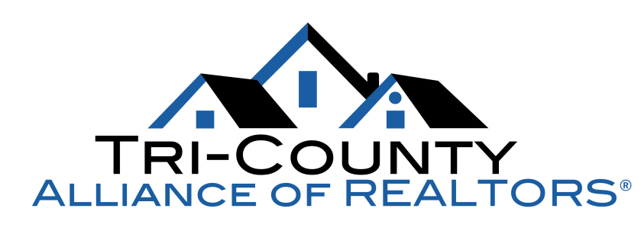

MAY BREAKFAST MEETING

featuring our famous Lawyer Panel:
Stephen M. Bacon, Esp. of KAHAN, KERENSKY & CAPOSSELA, LLP
David H. Blackwell, Esq. of Blackwell & Spadaccini, LLC
Gary D. Lavigne, Esq. of Lavigne, Mark, Rogers & Bruggeman, LLC

Topics of Discussion: Update on TRID

Thursday, May 19, 2016

A Villa Louisa
60 Villa Louisa Road in Bolton
8:30 a.m. sign-in 8:45 a.m. breakfast

Members $15 Non-Members $20

Sponsored by

*Full Breakfast Buffet *RPAC Prizes *Member Drawing
*Production Awards 3rd & 4th Quarter 2015 and 1st Quarter 2016

REGISTRATION REQUIRED BY MAY 16, 2016 – NO SHOWS WILL BE BILLED $20
__________________________________________________________________________

Name(s): Click here to enter text.

Office: Click here to enter text. Cell #: Click here to enter text.
Member: Choose an item. Non-Member: Choose an item.
Total Due: Click here to enter text. Payment Type: Choose an item.

